Software Architecture and Design Specification
Project: Campus Ride-Share Matching System (CampusRide)
Version: 1.0
Authors: Sarva Sandip, Sai Likhith, T Surya
Date: 10-10-2026
Status: Draft

Revision History
Version | Date | Author | Change Summary
1.0 | 10-10-2026 | Sarva Sandip, Sai Likhith, T Surya | Initial architecture and design for the Campus Ride-Share Matching System

Approvals
Role | Name | Signature / Date
Course Coordinator
Faculty Guide / Reviewer
Team Lead / Architect | Sarva Sandip

Project team
Member | Name | Role | Features built
Member 1 | Sarva Sandip | Team Lead, Product Owner and Software Architect; GitHub repository owner | Booking, Messaging, Notifications
Member 2 | Sai Likhith | QA Lead; test planning and requirements traceability | Ride offers/requests, Matching, Ratings & history
Member 3 | T Surya | Dev Lead (integration); security and performance testing | Authentication, Admin & moderation, End-to-end demo

1. Introduction

1.1 Purpose
This document specifies the architecture and design of the Campus Ride-Share Matching System (CampusRide). It explains how the requirements in the SRS are realised through components, data, interfaces and security controls, and records the key architectural decisions.

1.2 Scope
Covers the user-facing services: registration and verification, profiles and driver approval, ride offers and requests, route-based matching, booking lifecycle, in-app messaging, ratings and ride history, notifications and administration. Payments and live GPS tracking are outside the v1.0 scope.

1.3 Audience
Developers, QA engineers, security reviewers, UI/UX designers, instructors and the maintenance team.

1.4 Definitions
CRMS (Campus Ride-Share Matching System), OTP, JWT, RBAC, REST, WSS, PostGIS, ADR (Architecture Decision Record), STRIDE, TLS, PII, API, UML.

2. Document Overview

2.1 How to use this document
Provides the architectural deliverables: component and class (UML) diagrams, architecture decision records (ADRs), the matching-algorithm and data design, sequence diagrams for key flows, API design, security architecture (STRIDE threat model) and UX design. Section 3 describes the architecture; Section 4 describes the detailed design.

2.2 Related Documents
SRS (CampusRide SRS v1.0), STP (CampusRide Test Plan v1.0) and the Requirements Traceability Matrix (RTM, SRS Section 8).

3. Architecture

3.1 Goals & Constraints
Goals: secure and privacy-preserving, reliable (99.5% monthly availability), responsive match search (<= 3 s p95), modular and maintainable, accessible (WCAG 2.1 AA) and easy for students to use on a phone.
Constraints: access limited to institutional email holders; compliance with data-protection law and institutional policy; third-party map API quotas; mostly open-source stack and small team; one-semester delivery; browser-based client only (no native apps).

3.2 Stakeholders & Concerns
Stakeholder | Concerns
Riders (students) | Safety, quick relevant matches, privacy of location/phone, simple UI, availability
Drivers (students) | Easy posting (incl. recurring), control over who joins, trust in riders, low detour
Campus Safety Office / Admins | Driver verification, moderation tools, audit trail, configurable rules
University IT | Security, institutional email domain control, data protection, hosting cost
Developers / Maintainers | Modularity, testability, clear APIs, observability
Evaluators / Instructors | Traceability to requirements, quality of design artefacts

3.3 Component (UML) Diagram
Figure 1 shows the logical components arranged in layers. Figure 2 shows the main domain classes (UML class diagram) that the services operate on.
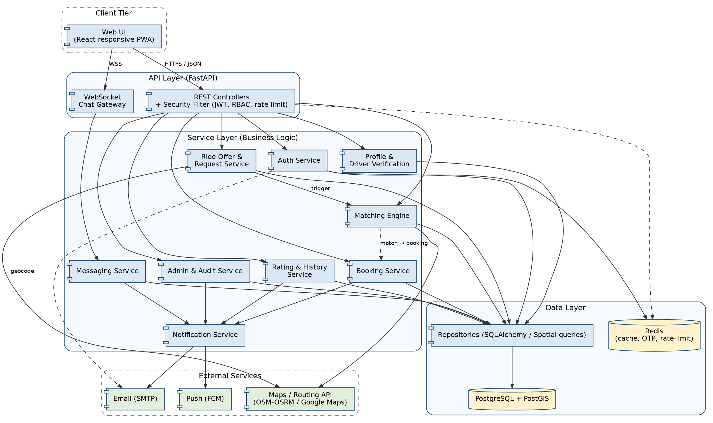
Figure 1: UML component diagram - CampusRide layered architecture
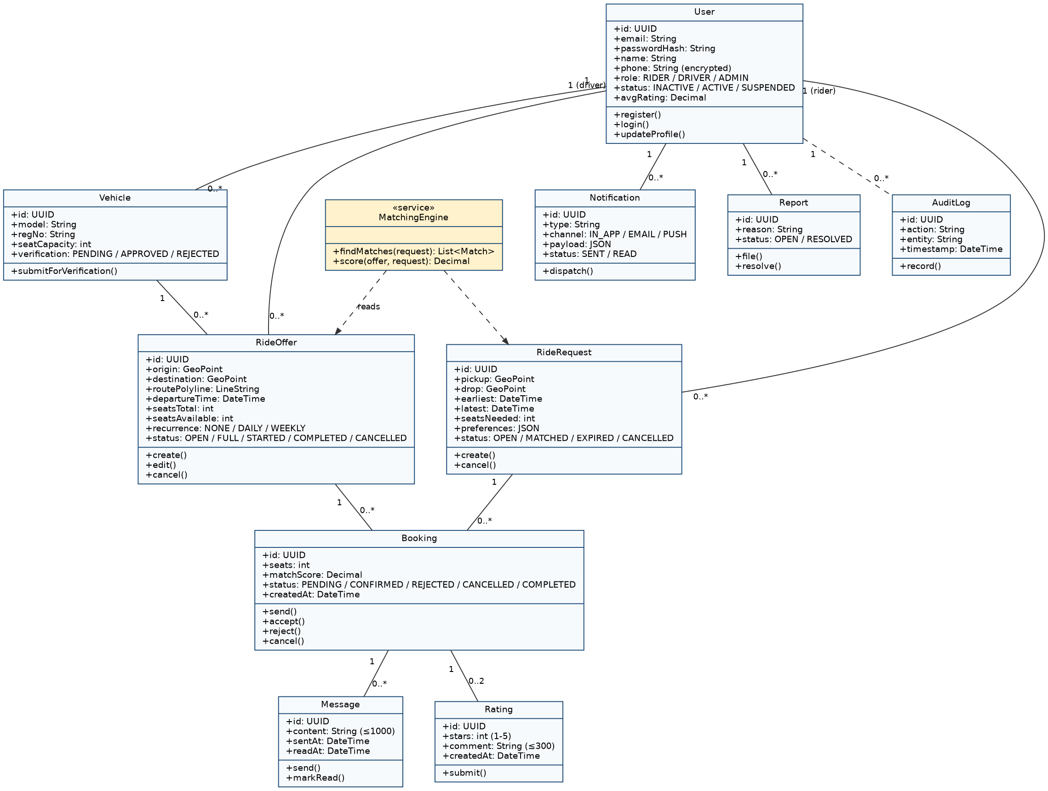
Figure 2: UML class diagram - core domain model

3.4 Component Descriptions
Component | Responsibility
Web UI (React PWA) | Responsive client: forms, map picker, match results, chat, history, admin screens; calls REST and WebSocket APIs.
REST Controllers + Security Filter | Entry point for all API calls; validates input, authenticates JWT, enforces RBAC and rate limits, maps errors to standard responses.
Chat Gateway (WebSocket) | Authenticated real-time channel for chat; hands messages to the Messaging Service.
Auth Service | Registration with institutional-email check, OTP verification, login, lockout, password reset, token issue/revocation.
Profile & Driver Verification | User profile, vehicle and licence data, driver application state; privacy rules for phone/location.
Ride Offer & Request Service | Create/edit/cancel offers and requests, location validation and geocoding, recurrence expansion.
Matching Engine | Finds compatible offers for a request (and requests for an offer), scores and ranks them, re-evaluates on changes.
Booking Service | Booking state machine (pending, confirmed, started, completed, cancelled, expired), atomic seat allocation, overlap check, trusted-contact share link.
Messaging Service | Authorises chat by booking, persists messages, delivery/read status, block and report, read-only after 24 h.
Rating & History Service | Ride history queries, mutual ratings, average rating computation, flagging.
Notification Service | Event-to-notification mapping, channel preferences, queue with retry for email/push, departure reminders (scheduler).
Admin & Audit Service | Driver verification queue, moderation and sanctions, configuration, analytics, append-only audit log.
Repositories / Database | SQLAlchemy repositories and GeoAlchemy2 spatial queries on PostgreSQL + PostGIS; Redis for OTP, rate-limit counters and short-lived caches.
External services | Maps/routing (geocoding, route polylines), SMTP email, push (FCM).

3.5 Chosen Architecture Pattern and Rationale
A layered, modular-monolith architecture (presentation, API, service, data) was chosen. Modules have clear boundaries and communicate through interfaces, giving separation of concerns and easy testing while keeping deployment simple for a campus-scale system (target 10,000 users). Microservices were rejected as unnecessary operational complexity for the team size and load. An event-driven element (internal queue) is used only for notifications so that external provider outages do not block ride flows.

Architecture Decision Records (ADRs)
ADR | Decision | Status | Rationale and alternatives considered
ADR-001 | Layered modular monolith (Python / FastAPI) | Accepted | Simple deployment, one codebase, transactional consistency for seat allocation. Microservices rejected: overhead, distributed transactions.
ADR-002 | PostgreSQL + PostGIS | Accepted | Native geospatial indexing (GiST) for route-proximity queries and ACID transactions. MySQL spatial support considered but weaker for line-distance queries; NoSQL rejected for transactional needs.
ADR-003 | WebSocket (FastAPI/Starlette) for chat with REST fallback | Accepted | Low-latency delivery (<= 2 s) and read receipts. Polling rejected: latency and load.
ADR-004 | Maps access through an adapter interface (OSRM or Google Maps) | Accepted | Avoids vendor lock-in and allows fallback to straight-line distance if the provider is down.
ADR-005 | JWT in HttpOnly cookies with 30-minute expiry and server-side revocation list (Redis) | Accepted | Stateless scaling with the ability to revoke on logout, password change and suspension. Local storage tokens rejected (XSS risk).
ADR-006 | Two-stage matching: spatial/time pre-filter in SQL, then scoring in application code | Accepted | Keeps match search <= 3 s with 5,000 active offers; scoring logic stays testable and configurable.
ADR-007 | Approximate location before confirmation | Accepted | Privacy by design: exact pickup, phone and vehicle number only revealed to confirmed partners.

3.6 Technology Stack & Data Stores
Area | Choice
Frontend | React (responsive PWA), Leaflet/OpenStreetMap or Google Maps JS for the map picker, WCAG-compliant component library
Backend | Python 3.12, FastAPI + Uvicorn (REST and WebSocket, automatic OpenAPI/Swagger), Pydantic validation, SQLAlchemy 2 + GeoAlchemy2, APScheduler for scheduled jobs
Implementation | Core domain library campusride (src/campusride/): auth, rides, geo, matching, booking, messaging, ratings, notifications, admin - one module per service in Figure 1, developed feature-by-feature on Git branches and verified by pytest in CI
Database | PostgreSQL 15 + PostGIS (primary store); Alembic migrations
Cache / Queue | Redis (OTP, rate limiting, revocation list); in-process queue (asyncio background tasks) for notifications
External | Routing/geocoding: OSRM or Google Maps API; Email: SMTP; Push: Firebase Cloud Messaging
Security | TLS 1.2+, bcrypt/Argon2, AES-256 field encryption, OWASP-aligned input validation
DevOps | Docker Compose, Nginx reverse proxy (TLS termination), GitHub Actions CI (pytest on every pull request; protected main), Prometheus + Grafana monitoring
Testing | pytest, pytest-cov, testcontainers-python, httpx, Postman/Newman, Selenium, JMeter, OWASP ZAP, axe
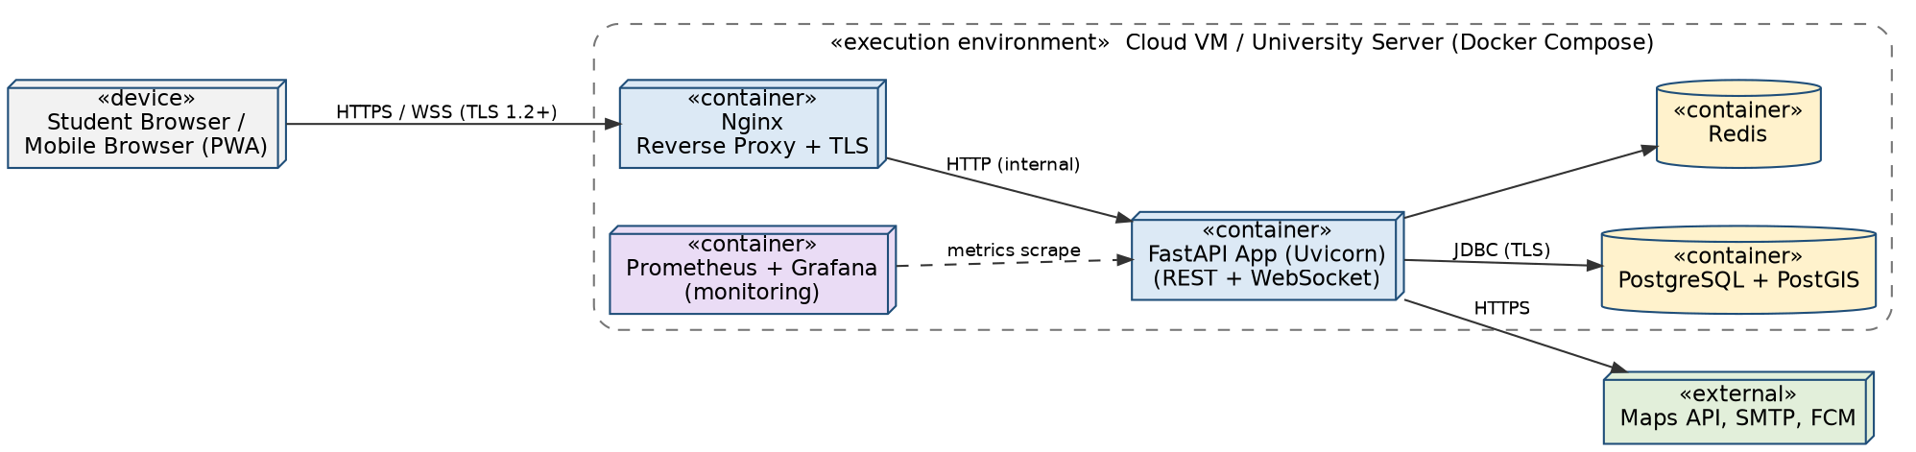
Figure 3: UML deployment diagram

3.7 Risks & Mitigations
Risk | Mitigation
Maps/routing API outage or quota exhaustion | Adapter with caching of geocodes/routes, circuit-breaker and fallback to straight-line distance; quota monitoring
Overbooking when several acceptances occur together | Atomic conditional update (seats >= n) inside a transaction; concurrency test TC-Match-06
Low initial participation (too few offers) - poor matches | Recurring offers, 'notify me when a match appears', configurable wider radius, campus-wide launch
Safety incidents or fake drivers | Institutional email, admin-approved drivers, ratings, report/block, trusted-contact sharing, audit log
Leakage of location or phone data | Approximate locations until confirmation, field-level encryption, RBAC, privacy tests (TC-Sec-05)
Match search too slow at peak times | GiST spatial index, bounding-box and time pre-filter, caching of routes, load tests (TC-Perf-01)
Spam or abuse in chat and requests | Rate limiting, content limits, report/block, admin moderation
Email/push provider delays or failure | Queue with retry and back-off; in-app notification always available
Single server failure | Daily backups (RPO 24 h), health checks, documented restore (RTO 4 h), container auto-restart

3.8 Traceability to Requirements
Requirements | Component(s) | Design section | Design spec ID
CRS-F-001 to 004 (registration, login, lockout, reset) | Auth Service | 4.2 (Seq. 2), 4.3 | DS-Auth-01
CRS-F-005, 006 (profile, driver verification) | Profile & Driver Verification | 4.1, 4.3 | DS-Prof-01
CRS-F-010 to 014 (offers, requests, locations) | Ride Offer & Request Service | 4.1, 4.3 | DS-Ride-01
CRS-F-015, 030 to 036, 024 (booking, seats) | Booking Service | 4.2 (Seq. 1, 3), 4.3 | DS-Book-01
CRS-F-020 to 025 (matching) | Matching Engine | 4.1.2, 4.2 (Seq. 1) | DS-Match-01
CRS-F-040 to 044 (messaging) | Messaging Service, Chat Gateway | 4.2 (Seq. 4), 4.3 | DS-Msg-01
CRS-F-050 to 053 (history, ratings) | Rating & History Service | 4.2 (Seq. 3), 4.3 | DS-Rate-01
CRS-F-060 to 062 (notifications) | Notification Service | 3.4, 4.4 | DS-Notif-01
CRS-F-070 to 074 (administration, audit) | Admin & Audit Service | 3.9, 4.3 | DS-Admin-01
CRS-NF-001 to 003 (performance, scalability) | Matching Engine, DB indexes, app tier | 3.5 (ADR-006), 4.1 | DS-Perf-01
CRS-NF-004, 005 (availability, backup) | Deployment, DB | 3.6, 3.7 | DS-Rel-01
CRS-NF-006, CRS-SR-001 to 010 (privacy, security) | Security filter, all services | 3.9 | DS-Sec-01
CRS-NF-007 to 009 (usability, accessibility, compatibility) | Web UI | 4.5 | DS-UX-01
CRS-NF-010 (maintainability) | All modules (layering, OpenAPI) | 3.5 | DS-Arch-01
CRS-NF-011 (retention) | Admin & Audit Service, DB jobs | 4.4 | DS-Ops-01

3.9 Security Architecture
Trust boundaries: (1) browser to Nginx/API over TLS; (2) application to database/cache inside the private network; (3) application to external providers over HTTPS. All entry points pass through the Security Filter (JWT validation, RBAC, rate limiting, input validation).

Threat modelling (STRIDE)
Threat | Example in CampusRide | Mitigation
Spoofing | Outsider registers or impersonates a student; stolen credentials | Institutional-email OTP verification, bcrypt/Argon2 hashing, lockout after 5 failures, short-lived JWT (CRS-SR-002, 007)
Tampering | Altering booking or seat counts, rating manipulation, modifying request parameters | Server-side validation and authorisation, atomic transactions, immutable ratings, CSRF protection (CRS-SR-003, 005)
Repudiation | Admin or user denies an action such as a sanction or cancellation | Append-only audit log with actor, entity and timestamp (CRS-SR-009, CRS-F-074)
Information disclosure | Exact location/phone exposed, IDOR on bookings or chats, data in transit sniffed | Approximate locations until confirmation, field encryption, per-user authorisation checks, TLS 1.2+, no sensitive data in logs (CRS-SR-001, 003, 004, 008)
Denial of service | Request/OTP/chat flooding, expensive match queries | Rate limiting (login, OTP, chat), query pre-filter and indexes, timeouts and circuit breakers (CRS-SR-006)
Elevation of privilege | Rider acts as admin or unapproved driver posts offers | RBAC enforced server-side on every endpoint, driver-approval check, admin area separated and audited (CRS-SR-003)

Additional controls: secure file upload (type, size, random names, outside web root), secrets in environment/secret store (not in code), dependency scanning in CI, and OWASP ZAP scans before release.

4. Design

4.1 Design Overview
CampusRide is designed as layered modules: controllers (API) call services; services contain business rules; repositories encapsulate persistence. Each module owns its tables and exposes interfaces to others, which keeps maintenance simple and allows later extraction into services if needed.

4.1.1 Data Design
Main entities are shown in Figure 2. Key tables and indexing:
Table | Key columns | Indexes / notes
users | id, email (unique), password_hash, name, phone_enc, role, status, avg_rating | Unique index on email; phone encrypted (AES-256)
vehicles | id, user_id, model, reg_no, seat_capacity, verification_status | FK to users; admin decision stored
ride_offers | id, driver_id, vehicle_id, origin, destination, route (LineString), departure_time, seats_total, seats_available, recurrence, status | GiST index on route; B-tree on (status, departure_time)
ride_requests | id, rider_id, pickup, drop, earliest, latest, seats_needed, preferences, status | GiST on pickup/drop; B-tree on (status, earliest)
bookings | id, offer_id, request_id, rider_id, seats, match_score, status, created_at | Unique (offer_id, rider_id) for pending/confirmed; FK indexes
messages | id, booking_id, sender_id, content, sent_at, read_at | Index on (booking_id, sent_at)
ratings | id, booking_id, rater_id, ratee_id, stars, comment, created_at | Unique (booking_id, rater_id)
notifications | id, user_id, type, channel, payload, status, created_at | Index on (user_id, status)
reports / audit_log / config | report details, append-only audit entries, key-value system parameters | audit_log: insert-only privileges for the application role

4.1.2 Matching Algorithm Design
Matching uses two stages (ADR-006) for each ride request R and each open offer O:
- Pre-filter (SQL): O.status = OPEN, O.seats_available >= R.seats_needed, O.departure_time inside [R.earliest, R.latest], and ST_DWithin(O.route, R.pickup, radius) AND ST_DWithin(O.route, R.drop, radius). Default radius = 1 km (configurable).
- Direction check: project pickup and drop on the route (ST_LineLocatePoint); keep the offer only if pickup position < drop position along the route.
- Preference and block filter: exclude blocked users and offers that violate rider preferences (for example same-gender only).
- Scoring: compute the compatibility score below and sort in descending order; ties are broken by earlier departure time.

score = 0.40 * (1 - detour / maxDetour) // detour = pickup + drop distance from route
+ 0.30 * (1 - |departure - preferredTime| / timeWindow)
+ 0.20 * (driverRating / 5) // 'New' drivers use a neutral 0.6
+ 0.10 * preferenceMatch // 1.0 if all optional preferences met
range 0..1; shown to the user as a percentage
Seat allocation uses a single conditional statement inside the accept transaction: UPDATE ride_offers SET seats_available = seats_available - :n WHERE id = :id AND seats_available >= :n; the booking is confirmed only if one row was updated, which prevents overbooking under concurrency (CRS-F-024).
Parameter (admin-configurable) | Default | Purpose
Matching radius | 1 km | Maximum distance from route to pickup/drop
Join-request expiry | 30 min | Auto-expire pending requests
Rating window | 7 days | Time allowed to rate after completion
Late-cancel threshold | 1 h before departure, 3 times / 30 days | Flag repeated late cancellations
Score weights | 0.4 / 0.3 / 0.2 / 0.1 | Detour / time / rating / preferences

4.2 UML Sequence Diagrams
Four sequence diagrams cover the flows specific to CampusRide: matching and booking, registration and login, ride completion with rating and history, and in-app chat.

Sequence 1: Post ride request, get matches and book a ride
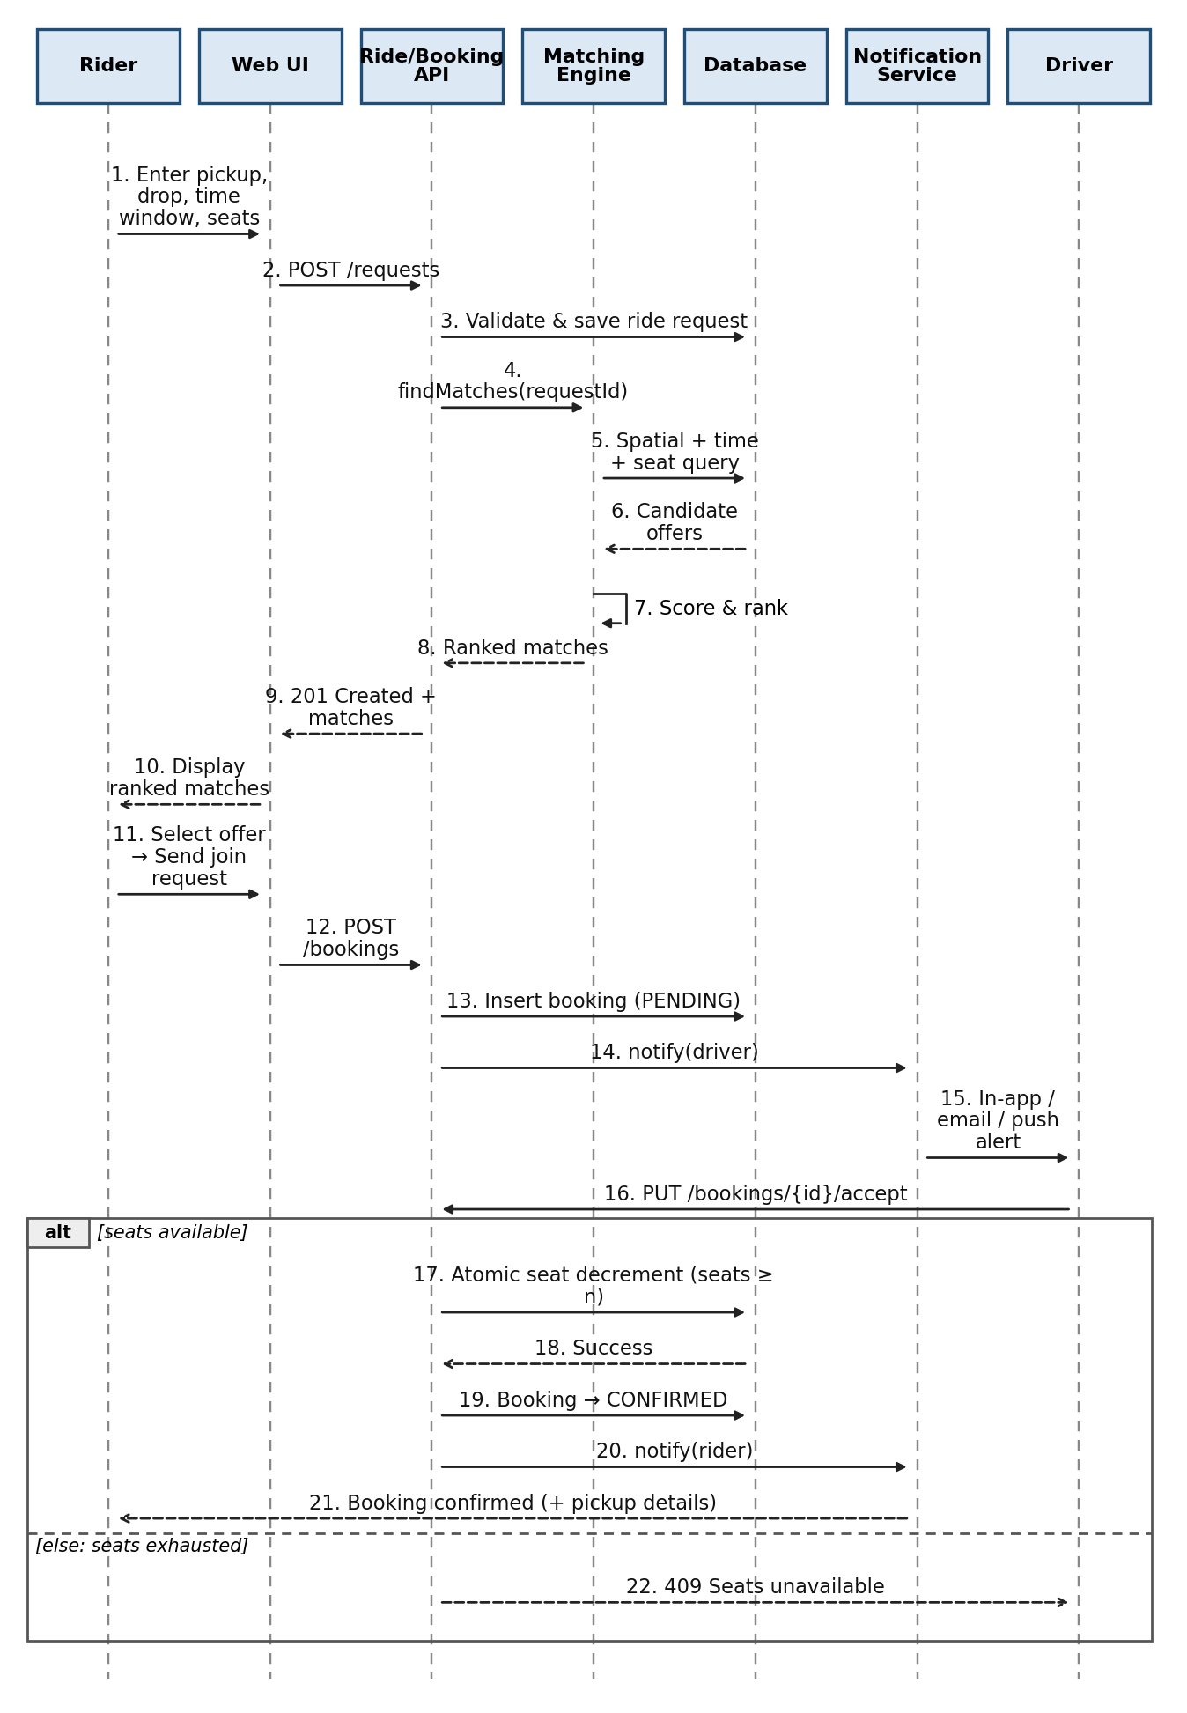
Figure 4: Sequence diagram - matching and booking (CRS-F-012, 020, 021, 024, 030-032, 060)

Sequence 2: Registration with email OTP and login
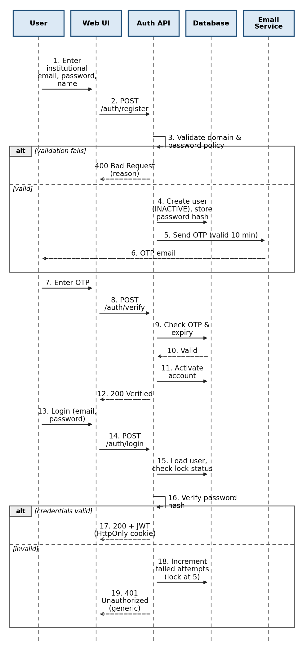
Figure 5: Sequence diagram - registration, verification and login (CRS-F-001 to 003)

Sequence 3: Complete ride, rate partner and view history
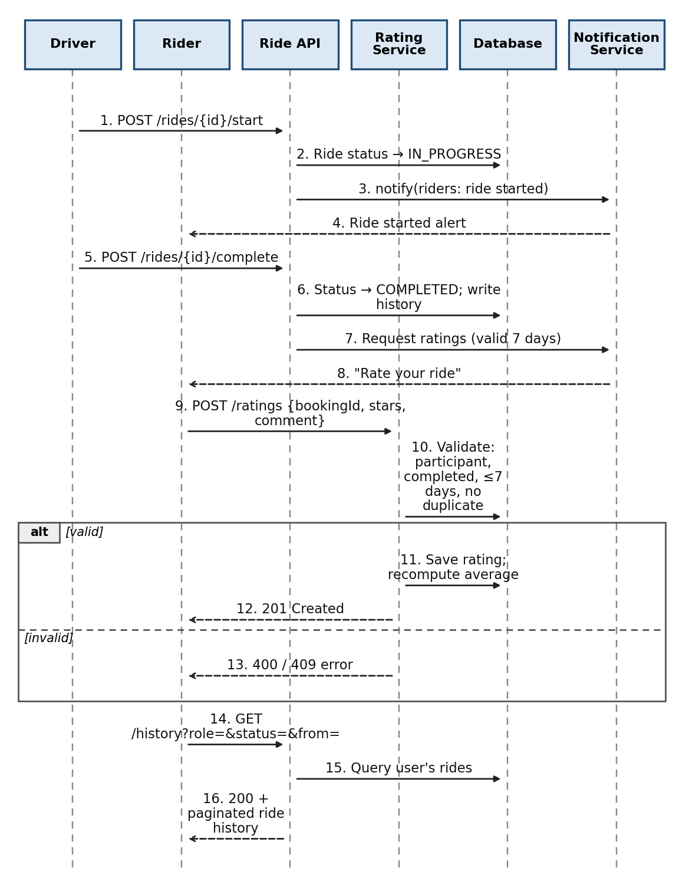
Figure 6: Sequence diagram - ride completion, rating and history (CRS-F-034, 050, 051)

Sequence 4: In-app chat
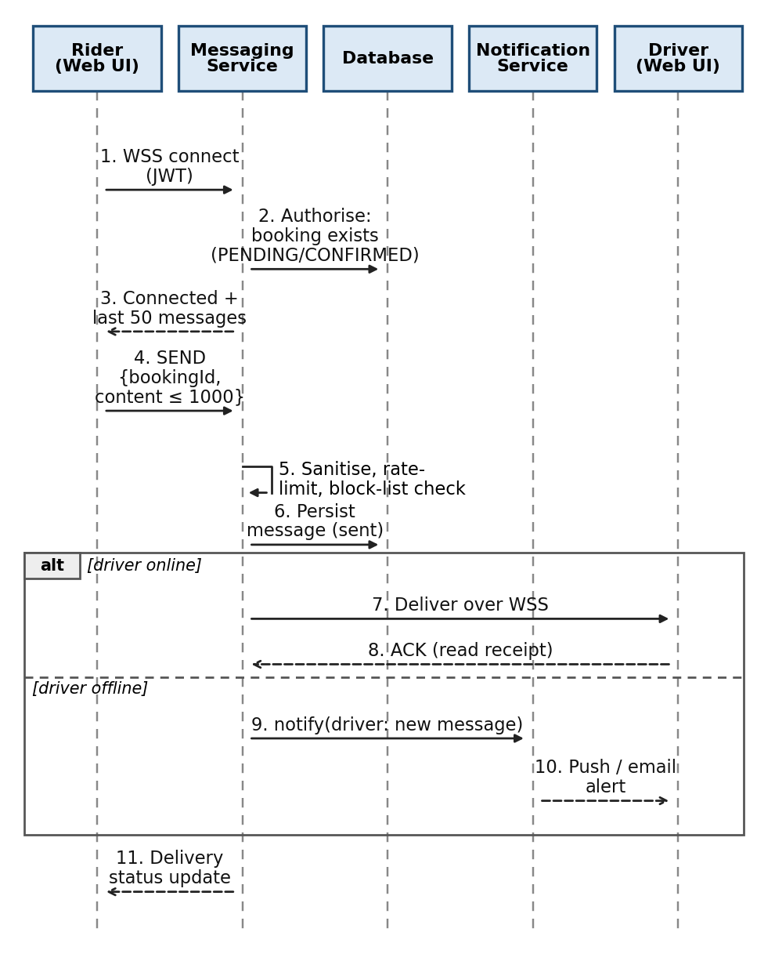
Figure 7: Sequence diagram - real-time chat (CRS-F-040 to 044)

4.3 API Design
All APIs are REST/JSON over HTTPS under /api/v1, documented with OpenAPI (Swagger). Authentication uses the JWT cookie unless marked public. Detailed interface definitions for the Auth, Ride Request/Matching and Booking components follow, then the endpoint catalogue.

Component 1: Auth Service - POST /auth/login
Endpoint / Method | /api/v1/auth/login - POST (public)
Request | { email, password }
Response (200) | { userId, name, role } + Set-Cookie: access_token (HttpOnly, Secure, SameSite=Strict, 30 min)
Errors | 401 Invalid credentials (generic message); 423 Account locked (15 min); 403 Account not verified; 429 Too many attempts

Component 2: Ride Request / Matching - POST /requests
Endpoint / Method | /api/v1/requests - POST (Rider)
Request | { pickup:{lat,lng,label}, drop:{lat,lng,label}, earliest, latest, seatsNeeded, preferences:{sameGenderOnly} }
Response (201) | { requestId, status:"OPEN", matches:[ { offerId, driverName, rating, departureTime, detourMeters, score, approxPickup } ] }
Errors | 400 Invalid time window or seats; 422 Location outside service area; 401 Unauthenticated; 409 Overlapping confirmed ride

Component 3: Booking Service - PUT /bookings/{id}/accept
Endpoint / Method | /api/v1/bookings/{id}/accept - PUT (Driver who owns the offer)
Request | (no body)
Response (200) | { bookingId, status:"CONFIRMED", seatsRemaining, pickup:{lat,lng,label}, rider:{name, phone} }
Errors | 403 Not the offer owner; 404 Booking not found; 409 Seats unavailable / already decided; 410 Request expired

Endpoint catalogue
Method | Endpoint | Role | Purpose (requirement)
POST | /auth/register | Public | Register with institutional email (CRS-F-001)
POST | /auth/verify | Public | Verify OTP and activate account (CRS-F-001)
POST | /auth/logout | Any user | End session and revoke token (CRS-SR-007)
POST | /auth/password-reset/request | /confirm | Public | Reset password via single-use link (CRS-F-004)
GET / PUT | /users/me | Any user | View / edit profile (CRS-F-005)
POST | /drivers/apply | Rider | Submit vehicle and licence for approval (CRS-F-006)
POST / PUT / DELETE | /offers, /offers/{id} | Driver | Create, edit, cancel ride offer (CRS-F-010, 011)
GET | /offers/{id}/candidates | Driver | Compatible requests for an offer (CRS-F-025)
PUT / DELETE | /requests/{id} | Rider | Edit / cancel ride request (CRS-F-013)
GET | /requests/{id}/matches?sort=&filter= | Rider | Ranked, filtered matches (CRS-F-020 to 023)
POST | /bookings | Rider / Driver | Send join request or invitation (CRS-F-030, 025)
PUT | /bookings/{id}/accept | /reject | Driver | Decide on request (CRS-F-031)
DELETE | /bookings/{id} | Rider / Driver | Cancel with reason (CRS-F-033)
POST | /rides/{offerId}/start | /complete | Driver | Ride lifecycle (CRS-F-034)
POST | /bookings/{id}/share | Rider | Trusted-contact share link (CRS-F-036)
GET / WS | /bookings/{id}/messages, /ws/chat | Booking partners | Chat history and real-time chat (CRS-F-040 to 044)
POST | /users/{id}/block | /report | Any user | Block / report user (CRS-F-042)
POST / GET | /ratings, /users/{id}/ratings | Participants | Submit and view ratings (CRS-F-051, 052)
GET | /history?role=&status=&from=&to= | Any user | Ride history (CRS-F-050)
GET / PUT | /notifications, /notifications/preferences | Any user | Notifications and preferences (CRS-F-060 to 062)
GET / PUT | /admin/drivers/pending, /admin/drivers/{id}/decision | Admin | Driver verification (CRS-F-070)
GET / PUT | /admin/reports, /admin/users/{id}/status | Admin | Moderation and sanctions (CRS-F-071)
GET / PUT | /admin/config | Admin | System parameters (CRS-F-072)
GET | /admin/analytics, /admin/audit-logs | Admin | Analytics, CSV export and audit log (CRS-F-073, 074)

4.4 Error Handling, Logging & Monitoring
- Standard error format: { timestamp, status, errorCode, message, traceId }. Messages are user-friendly and never reveal stack traces, SQL or whether an email exists.
- HTTP codes: 400 validation, 401 unauthenticated, 403 forbidden, 404 not found, 409 conflict (seats, duplicates, overlap), 410 expired, 422 business-rule violation, 423 locked, 429 rate-limited, 500 internal error.
- Logging: structured JSON logs with traceId; no passwords, OTPs, tokens, exact coordinates or phone numbers in logs. Security and admin events go to the append-only audit log; application logs retained 90 days, audit logs 1 year (CRS-NF-011).
- Monitoring: Prometheus metrics and Grafana dashboards for uptime, API latency (p95), match-search duration, booking failure/conflict rate, chat delivery latency, notification queue depth and external-API errors; alerts on availability and error-rate thresholds.
- Resilience: timeouts, retries with back-off and circuit-breaker for external APIs; notification queue with retry; health endpoints for container restarts.

4.5 UX Design
Mobile-first, simple flows, and accessible by design (WCAG 2.1 AA): large touch targets, high contrast, keyboard operation, screen-reader labels, scalable text and clear error messages. A first-time user should post a ride request in at most 5 steps and 2 minutes (CRS-NF-007).
Screen | Purpose and key elements
Register / Login | Institutional email, OTP entry, password rules, lockout and reset messages
Home / Find a Ride | Pickup/drop picker (landmark list, map pin, search), time window, seats, preferences; 'Search' button
Match results | Ranked cards with driver rating, departure, detour, score and approximate pickup; filters and sort; 'Send join request'
Offer a Ride | Route, stops, time, seats, recurrence; shows driver-approval status
My Rides / Booking details | Status timeline, accept/reject (driver), cancel, start/complete, share with trusted contact
Messages | Per-booking chat with delivery status, block/report menu
History & Ratings | Filterable list, rating dialog (stars + comment), average rating
Profile & Settings | Profile, vehicle, notification preferences, data export/delete
Admin dashboard | Verification queue, reports, users, configuration, analytics, audit log

4.6 Open Issues & Next Steps
- Future enhancements: fare estimation and cost sharing, live ride tracking, native mobile apps, calendar/timetable integration for automatic recurring offers, carbon-savings dashboard.
- Decide the production maps provider (OSRM self-hosted vs Google Maps) based on quota and cost.
- Confirm legal/insurance wording and data-retention periods with the university.
- Optional integration with the university SSO instead of email OTP.
- Tune score weights using real usage data after the pilot.

5. Appendices

5.1 Glossary
CRMS, Rider, Driver, Ride offer, Ride request, Booking, OTP, JWT, RBAC, PostGIS, PWA, STRIDE, ADR, TLS, PII, WSS, OpenAPI.

5.2 References
IEEE 42010 (architecture description), ISO/IEC/IEEE 29148, OWASP ASVS and Top 10, NIST SP 800-160, WCAG 2.1, PostGIS documentation.

5.3 Tools
Graphviz and PlantUML/draw.io (diagrams), Swagger/OpenAPI (API documentation), Docker, GitHub Actions, Prometheus and Grafana.

